

**PROCEEDINGS OF**

**NATIONAL CONFERENCE ON RECENT**

**ADVANCEMENTS and CHALLENGES IN**

**INFORMATION TECHNOLOGY**

**(NCRACIT-2023)**

**28th&29thApril2023**

**ISBN: 978-93-5906-181-8**

**Organized By**

**School of Computer Science Engineering&**

**Information Science**

**Presidency University**

**Bengaluru**

[www.presidencyuniversity.in](http://www.presidencyuniversity.in/)

**Bed Management Optimisation**

**Paper ID-207**

SAYA VAMSHI KRISHNA

20191IST0198  
*Information Science &  
Technology*  
Presidency UniversityBangalore,India

201910100508@presidencyuniversity.in

DRISHITHA MISHRA

20191IST0042  
*Information Science &  
Technology*  
Presidency UniversityBangalore,India

201910101662@presidencyuniversity.in

SNEHA K M

20191IST0190  
*Information Science &  
Technology*  
Presidency UniversityBangalore,India

201910101605@presidencyuniversity.in

JEFIN JOMON

20191IST10062  
*Information Science &  
Technology*  
Presidency UniversityBangalore,India

201910100914@presidencyuniversity.in

AKASH K S

20191IST0005  
*Information Science &  
Technology*  
Presidency UniversityBangalore,India

201910100694@presidencyuniversity.in

*Abstract*—The "Bed Management Optimization" project aims to automate and streamline the Front Office Bed Management process in healthcare facilities through the development of a user-friendly and cost-effective website. The website will allow User to access real-time bed availability information, automate bed assignments, and improve communication among Hospital staff members. The website is designed with simplicity and ease of use in mind, requiring minimal training for Hospital staff members to adapt and navigate the system. The use of modern web technologies will ensure that the website is robust and scalable, optimizing resource utilization, reducing costs, and improving patient care and experience. The project aims to revolutionize the bed management process, enhance operational efficiency, and contribute to improved patient outcomes healthcare facilities.

Key Words-Bed Management ,Health Sector,Medical,Technology,Python,HTML& CSS

# **Introduction**

Bed management optimisation is a crucial aspect of healthcare management that involves the efficient allocation and utilisation of hospital beds. In the healthcare industry, bed management optimisation has become an essential strategy for reducing hospital costs, improving patient outcomes, and ensuring the delivery of high-quality care.

This project aims to provide healthcare professionals with valuable insights and practical tools for optimising the allocation and utilisation of hospital beds. Bed management optimisation is an essential strategy for healthcare providers to improve patient outcomes, reduce costs, and increase efficiency. This web page project aims to serve as a comprehensive resource for healthcare providers, administrators, and policymakers who are seeking to improve their bed management processes. Ease of Use[1]

## Objectives

* Create a user-friendly web page that allows users to quickly access hospital bed availability information
* Develop a system that allows hospitals to easily manage their bed availability data
* Provide real-time updates on the availability of hospital beds by creating dashboards
* Allow users to search for beds based on medical urgency ,speciality, and other criteria
* Facilitate communication between hospitals and patients regarding bed availability
* Develop an intuitive interface that enables User to easily adjust the availability of beds.
* Implement a system that allows hospitals to track how many beds are available at any given time. [2]

# **Literature Survey**

* The paper titled "Hospital Management and Control System, Volume 7, 2020" highlights the significant growth of the Network of Medical Records due to increasing patient demands. It emphasizes the importance of providing prompt and precise medical services to patients through the efficient utilization of patient management systems. The paper also emphasizes the crucial role of patient information options equipped in the healthcare sector and the need for modifications or specialized software creation based on unique patient specifications. The research focuses on evaluating and recognizing the core elements of Electronic Health Management System and Hospital Information System, considering their global requirements and administration. The success of these systems is often measured through a benchmarking viewpoint.[3]
* The article titled "HAMS: An Integrated Hospital Management System to Improve Information Exchange" highlights the importance of communication between hospitals and emergency care providers during times of crisis. It is crucial for hospitals to share information about their resources, such as bed and staff availability, so that first responders can manage patient flow efficiently. This leads to improved response time and resilient health services during emergencies. The successful management of crises depends on each healthcare facility's awareness of their own resource status and the availability of reliable and understandable information in a timely manner.[4]
* The article outlines a proposal for a web-based application for managing beds in hospitals. The aim is to allocate beds more efficiently to reduce the number of patients who need to be transferred to other facilities, which can result in longer stays. The application is intended to be integrated with an existing facility management system, which will provide information about the number and location of beds in each room. The system will analyze patient interaction, admission status, and staff to help reduce hospital costs and length of stay. It is important to note that the article does not include a review of existing literature.[5]
* In the paper, the topic of managing hospital beds and the flow of patients in emergency rooms is discussed. A computer simulation study was conducted using actual hospital data to assess the impact of various patient prioritization scenarios. The study compared four scenarios, which included prioritizing emergency and surgery, emergency and medicine, planned admissions and surgery, and planned admissions and medicine. The most effective scenario was found to be prioritizing planned admissions and surgery. The paper contributes to the current understanding of hospital management by demonstrating that changing bed management policies can enhance patient flow and reduce the duration of their stay..[6]
* In the paper, the use of Data Mining (DM) in hospital management is explored. The aim is to find relevant patient data that can be used by managers to make informed decisions. The literature review section of the paper defines the hospital as a medical and social organization that offers a wide range of health services to the population. It also serves as a center for training health workers and conducting biosocial research. The section stresses the significance of managers having an in-depth understanding of the hospital's policies and services, including its strengths and weaknesses. This knowledge can help them identify areas that require improvement.[7]
* The management of hospital beds is a crucial aspect of elective patient admission and assignment planning, as discussed in this paper. The paper reviews previous studies on the subject, which have mainly focused on computing efficient assignments based on fixed estimates of patient length of stay and preferences. However, these approaches fail to consider the uncertainty of patient recovery or the impact of shared resources, such as combined bed capacities. The paper aims to overcome these limitations by introducing a cost function for patient admission that accounts for flexible length of stay predictions and aggregated resources. Additionally, the paper proposes multiple algorithmic techniques for solving the bed assignment problem.[8]

# **Analysis**

## Existing Methods-Drawbacks

There are several existing methods for bed management optimization in healthcare facilities, popularly including manual bed tracking and electronic bed management systems(semi-computerized), However both methods have limitations in addressing dynamic bed demand fluctuations and tracking beds across different units or departments. Manual systems, which rely on paper forms and decentralized data storage, can be time-consuming, prone to errors, and lead to incomplete or inconsistent information. There is a risk of forms being lost or misplaced, requiring additional effort for auditing and ensuring data integrity. Semi-computerized systems, while offering some benefits over paper-based methods, may still lack real-time updates, complete data integration, and automated processes. They may rely on manual data entry and have limited connectivity between different departments, resulting in delays, data inconsistencies, and increased administrative work. Data privacy and security are also important considerations in these systems, requiring measures such as access controls, user authentication, and data encryption to protect sensitive information.

Furthermore, tracking and managing beds across different units or departments within hospitals can be challenging with these existing systems.While there are available methods for bed management optimization, many hospitals still face challenges in effectively managing their bed resources.[9]

## Proposed Method

The Bed Management optimization system aims to address the current challenges by introducing a digital way in the form of website that automates many of these tasks. This system will enable hospital staff to access patient records quickly and easily, update their hospital’s beds data information in real-time, and communicate more effectively with other healthcare professionals. This will help to improve patient outcomes and reduce the risk of errors or delays in care.

In addition to streamlining patient care, the Bed Management optimization webpage will also help hospitals to manage their resources more effectively. The system will allow user/patient to track room availability in real-time, which will help to reduce wait times for patients and improve overall experience. The system will also provide insights into operating room schedules, helping hospitals to optimize their use of these resources and reduce costs.

Overall, the Bed Management optimization system is a powerful tool that will help hospitals to improve patient care, reduce costs, and increase efficiency. By providing a comprehensive solution for managing patient information and hospital resources, this system will enable healthcare professionals to work more effectively, collaborate more efficiently, and provide better care to their patients. The ultimate aim is to provide these services in a way that is both efficient and cost-effective, with the goal of reducing the time and resources currently required for these tasks.

## Advantage of Proposed Method over Existing Models

* Centralization and Accessibility:The webpage centralizes hospital information, making it easier for patients to access bed availability across multiple hospitals.
* Efficient Bed Allocation:Real-time updates on bed availability enable efficient resource management and timely bed allocation.
* Streamlined Patient Admissions:Features such as waitlist management streamline patient admissions and prioritize patient needs.
* Enhanced Healthcare Coordination:The webpage facilitates communication and coordination among hospitals, patients, and healthcare providers, enhancing care transitions.
* Resource Optimization: Hospitals can optimize resources based on a comprehensive view of bed availability, leading to cost savings and improved patient care.
* Expansion and Scalability: The webpage is designed to accommodate network expansion, allowing more hospitals to join and promoting competition for better healthcare services.

## Workflow with modules

The Website consists of three modules: admin, user hospital User. The admin module is operated by administrators to Register the new Hospital data and store the information in database and reflect it in the website, while the Hospital user module is used by hospital staff and to handle the hospital data in the bed management and provide the real-time bed tracking in the website and patients/user module, needed to register via signup once data is stored , user can login, check the real-time data of available bed and book slot of bed according to need and medial urgency .

The workflow for a User/Patient begins with the registration process, where they create an account by providing the necessary details. Once registered, the user can log into the system using their credentials. They can then initiate a search for available beds based on their desired location and specialty. After finding a suitable bed, the user selects it based on their specific needs and preferences. To complete the booking process, the user enters relevant details required by the system. They then have the opportunity to review and confirm the booking details before finalizing the reservation. Once confirmed, the user receives a confirmation of the bed booking. In case of any inquiries or changes, the user can communicate directly with hospital staff through the system to address their concerns. This workflow ensures a streamlined and user-friendly experience for patients seeking bed availability information and booking in healthcare facilities.

The workflow for a Hospital User/Patient begins with logging into the bed management system using their credentials. Once logged in, the hospital user gains access to the system's dashboard, which provides an overview of bed availability throughout the facility. Using real-time information, the hospital user can add, update, or delete bed availability data as needed. Accuracy in entering and updating bed availability details is crucial to ensure the system reflects the most current information. The hospital user promptly updates the bed data to reflect the current availability status. Additionally, the hospital user is responsible for managing access rights and permissions for other staff members using the system. This ensures that only authorized personnel have the appropriate access levels. The hospital user also coordinates with other hospital staff to gather accurate and up-to-date information for the system, ensuring that the bed availability data is reliable and reflects the actual state of the facility. This workflow allows the hospital user to efficiently manage and update bed availability data while maintaining the accuracy and integrity of the system.

Fig 1. Context Level Diagram Explains the Methodology of the Website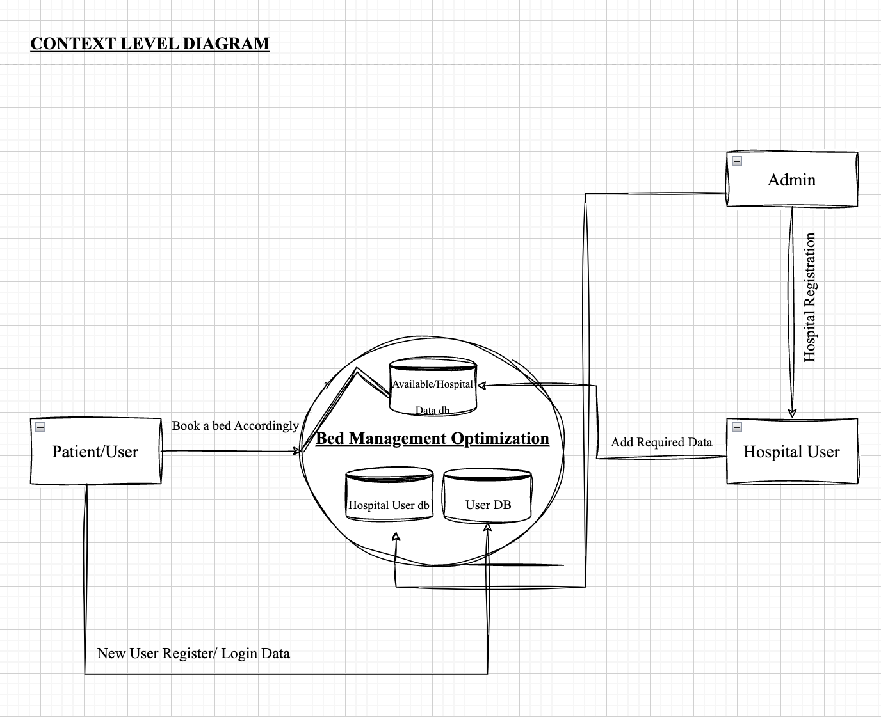

Fig 2 . Data Flow Diagram of the Website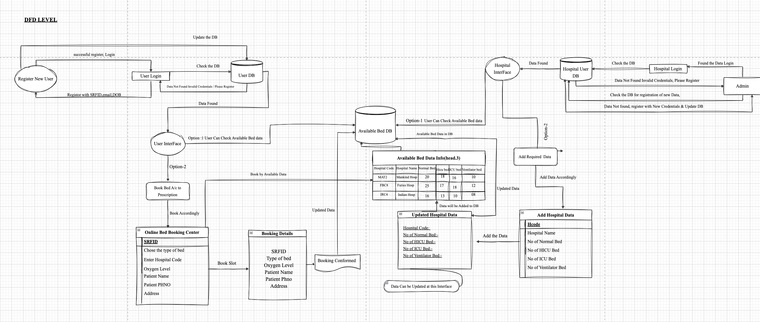

## Expected Outcomes

Bed Management Optimization web page would be to improve the efficiency and effectiveness of managing beds within a healthcare facility. This can be achieved by providing real-time data on bed availability, patient status, and hospital capacity, allowing healthcare professionals to make informed decisions and optimize bed utilization.

Some potential benefits of such a web page could include:

* Improved patient outcomes:
* Reduced costs
* Increased capacity:
* Improved data analysis
* Improved Patient Care & Experience

Overall, a bed management optimization web page has the potential to help healthcare facilities provide better care to their patients, while also improving efficiency and reducing costs.

# **Conclusion**

Bed management optimization is a critical component of hospital operations and plays a vital role in ensuring that patients receive timely and efficient care.

The online web page for bed management optimization is a valuable resource for healthcare organizations looking to improve their bed management processes. By providing access to real-time bed availability information, patient flow data, and predictive analytics, this web page can help healthcare providers make informed decisions about patient care and resource allocation.

By utilizing the tools and resources available on this web page, healthcare organizations can streamline their operations, reduce costs, and improve the overall quality of care they provide to their patients.

Overall, a well-designed bed management optimization web page can help healthcare organizations streamline their operations and improve the quality of care they provide to their patients.

##### **References**

[1] Abedian, Somayyeh, et al. "Cross hospital bed management system." *e-Health–For Continuity of Care*. IOS Press, 2014. 126-130.

[2]de SOUZA, M.C., SOUZA, T.A. and VACCARO, G.L., 2016. Hospital bed management: an analysis from the perspective of the theory of constraints. *Revista ESPACIOS| Vol. 37 (Nº 30) Año 2016*.

[3] Hospital Management and Control System ISSN 2515- 8260, Volume 7, June 2020 (European Journal of Molecular & Clinical Medicine): Ashmita Gupta, Ashutosh Niranajan, School of Medical Sciences & Research, Uttar Pradedesh

[4]HAMS: An Integrated Hospital Management System to Improve Information Exchange, CISIS- June, 2020: Francesco Lubrano, Federico Stirano, Gluseppe Varavallo, Fabrizio Bertone, Olivier Terzo

[5]Schmidt, Robert, Sandra Geisler, and Cord Spreckelsen. "Decision support for hospital bed management using adaptable individual length of stay estimations and shared resources." *BMC medical informatics and decision making* 13.1 (2013): 1-19.

[6]Claret, Pierre-Géraud, et al. "Consequences for overcrowding in the emergency room of a change in bed management policy on available in-hospital beds." Australian Health Review 40.4 (2015): 466-472.

[7]Iadanza, E., A. Luschi, and A. Ancora. "Bed management in hospital systems." World Congress on Medical Physics and Biomedical Engineering 2018: June 3-8, 2018, Prague, Czech Republic (Vol. 3). Springer Singapore, 2019.

[8] Balaji, Ramachandran, and Mark Brownlee. "Bed management optimization." From Infosys: http://www. infosyspublicservices. com/industries/healthcare/Documents/hospital-bed-management. pdf (2009).

[9]Oliveira, Sérgio, et al. "Predictive models for hospital bed management using data mining techniques." New Perspectives in Information Systems and Technologies, Volume 2. Springer International Publishing, 2014.